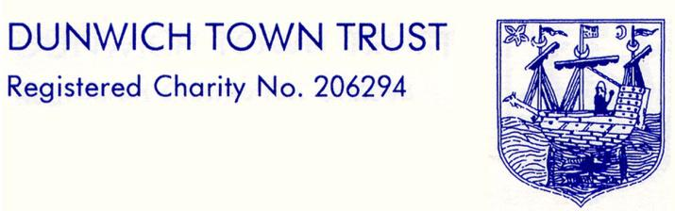

DUNWICH TOWN TRUST MEETING HELD
ON MONDAY 12 SEPTEMBER 2022
AT 6pm IN THE READING ROOM
MINUTES

1. Welcomes and Apologies
Present
Miss Nick Mayo (NM) (Chairman)
Ms Gussie Andersen (GA) (Vice- Chair)
Dr Dennis Cox (DC)
Ms Jane Hamilton (JH)
Mr Julian Perry (JP)
Ms Val Bethell (VB)
Mr Henry Tomlinson (HT).
In attendance: Mr John Lavery (Clerk) (JL).
Apologies were received from Mr Rod Smith (RS), Mr Crispin Clay (CC) and Mrs Nicky Kinahan (NK) (Treasurer)

The meeting was declared quorate.
No conflicts of interest were declared.

2. Minutes of Meeting on 11 July 2022
No amendments had been proposed since the draft minutes went out to Trustees. The Chairman signed the minutes as a true record.

- Matters Arising from the Minutes
There was only one action point, covered elsewhere on the agenda.

4. Clerk’s Report
Circulated, most issues covered in more detail elsewhere on the agenda.
The phone caller who had called previously seeking an educational grant contacted the Clerk again. Since then, an application had been received. The applicant lived in Theberton and the application was considered later in the meeting.

5. Car Park/Beach
NM dealt with flyers from the Ship advertising fish and chips on the Car Park. Flyers had been posted onto cars in the car park and one had been pinned to the beach café. Christian Elsley brought it to our attention, NM wrote to Chestnut Group who apologised immediately and promised that nothing like this would happen again.
NM received an email from Katherine Brookhouse, who recently moved to Dunwich. She recently provided community yoga in the Reading Room for residents of Dunwich and the surrounding area. As an extension to this service, she had also offered Beach Yoga with Coffee in collaboration with Flora Tea Rooms, which had been well received by Dunwich village locals, their guests, part-time residents, and holiday makers from the area. She was then advised that areas of the beach itself are owned by the DTT and apologised for not having been in contact earlier to discuss this. She had thought that by collaborating with C Elsley at the Tea rooms that she had covered all bases. She wanted to continue to offer this service through August and potentially through September, weather permitting. NM thinks we agreed to this already via Sharon Elsley, but in any event gave permission to Mrs Brookhouse. The Trustees were all happy with NM’s decision.

- Treasurer’s Report and Financial Matters
Accounts & financial report circulated by NK. Income in line with the budget, expenditure over budget because of unexpected repairs. Funds transfers effected in line with the Resolution passed at the last meeting.
NK is standing down at the next meeting. Would the replacement identified by CC like to attend that meeting and/or meet NK to discuss takeover. Trustees felt that this was a good idea. A.P. NM would contact NK & CC shortly to asked them to arrange a meeting with the prospective new Treasurer.

- Governance
NM asked JL if the policies that the Trustees amended at the last meeting were now up on the website. JL assured NM and the meeting that they were.
NM asked if succession planning for the Chairman’s position was being addressed by the Trustees. GA assured her that satisfactory progress was being made.

- Housing
No concerns had been expressed by the tenants and no adverse comments had come from C&S. Rent payments were up to date and repairs had been affected or were under way.

9. Grants
We had received a written thank you from Macmillan, asking for £1k donation. This can be considered with other group donations at the next meeting, where we will also be looking to agree Winter Fuel Grant payments for the year.
One application received for an education grant this was reported in the confidential section of the minutes

10. AOB
There were no further items of business.

Date of Next Meeting

7 November 2022 (note this is not the second Monday of the month), 6 p.m., in the Reading Room.

Signed:…………………………………………………………..

Dated:…………………………………………………………

